Zara Ahmed

FA25-BCS-060

Code#01
#include <iostream> using namespace std;

struct Node
{ int data;
Node* next; Node* prev;
};
// Head, Tail, First, Last
Node* head = NULL;
Node* tail = NULL;

Node* first = NULL;
Node* last = NULL;

// Insert node at end void insertEnd(int value)
{
Node* p = new Node; p->data = value; p->next = NULL; p->prev = NULL; if (first == NULL)
{
first = last = p; head = tail = p;
}
else
{
last->next = p; p->prev = last;

last = p; tail = p;
}
}
// Display list void display()
{
Node* p = head; cout << "List: "; while (p != NULL)
{
cout << p->data << " "; p = p->next;
}

cout << endl;
}
// Task 1: Reverse the Doubly Linked List void reverseList()
{
Node* p = head;
Node* temp;

while (p != NULL)
{
// Next aur previous ko swap karo temp = p->next;

p->next = p->prev; p->prev = temp;

p = temp;
}
// Head aur Tail swap temp = head; head = tail; tail = temp; // First aur Last update first = head; last = tail;
}

int main()
}
cout << "===== TASK 1 =====" << endl; cout << "Reverse Doubly Linked List" << endl; cout << endl; // Create list insertEnd(10); insertEnd(20); insertEnd(30); insertEnd(40); insertEnd(50); cout << "Before Reverse:" << endl; display(); // Reverse list reverseList(); cout << "After Reverse:" << endl; display();

return 0;
}
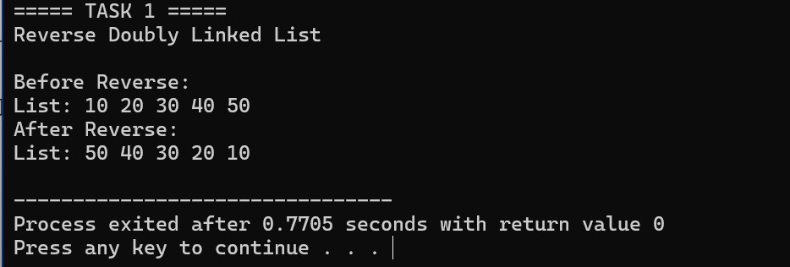

Code#02
#include <iostream> using namespace std; // Doubly Linked List Node struct Node
{ int data;
Node* next;
Node* prev;
};
// Head, Tail, First, Last
Node* head = NULL;
Node* tail = NULL;
Node* first = NULL;
Node* last = NULL; // Insert node at end void insertEnd(int value)
{
Node* p = new Node; p->data = value; p->next = NULL; p->prev = NULL; // If list is empty if (first == NULL)
{
first = p; last = p; head = p; tail = p;
}
else
{
last->next = p; p->prev = last;

last = p; tail = p;
}
}
// Display list void display()
{
Node* p = head; cout << "List: "; while (p != NULL)
{
cout << p->data << " "; p = p->next;
}

cout << endl;
}
// Search node
Node* searchNode(int value)
{
Node* p = head;

while (p != NULL)
{
if (p->data == value)
{
return p;
}
p = p->next;
}
return NULL;
}

void swapNodes(int value1, int value2)
{
Node* node1 = searchNode(value1); Node* node2 = searchNode(value2);

// Check both values if (node1 == NULL || node2 == NULL)
{
cout << "One or both values were not found." << endl; return;
}

// Same node if (node1 == node2)
{
cout << "Both values are in the same node." << endl;
return;
}

// Make node1 the node that comes first if (node1->prev == NULL)
{
// node1 is already first
}
else if (node2->prev == NULL)
{
Node* temp = node1; node1 = node2; node2 = temp;
}

// Save links
Node* before1 = node1->prev;
Node* after1 = node1->next;

Node* before2 = node2->prev;
Node* after2 = node2->next;

// =================================================
// CASE 1: Nodes are adjacent
// =================================================

if (after1 == node2)
{
// Connect before node1 if (before1 != NULL)
{
before1->next = node2;
} else
{
head = node2; first = node2;
}

// Connect after node2 if (after2 != NULL)
{
after2->prev = node1;
} else
{
tail = node1; last = node1;
}

// Swap links node2->prev = before1; node2->next = node1;

node1->prev = node2; node1->next = after2;
}

else
{
// Connect before node1 to node2 if (before1 != NULL)
{
before1->next = node2;
} else {
head = node2; first = node2;
}

// Connect after node1 to node2 if (after1 != NULL)
{
after1->prev = node2;
} else
{
tail = node2; last = node2;
}

// Connect before node2 to node1 if (before2 != NULL)
{
before2->next = node1;
} else
{
head = node1;
first = node1;
}

// Connect after node2 to node1 if (after2 != NULL)
{
after2->prev = node1;
} else
{
tail = node1; last = node1;
}

// Set node1 links node1->prev = before2; node1->next = after2;

// Set node2 links node2->prev = before1; node2->next = after1;
}

cout << "Both nodes swapped successfully." << endl;
}

// =====================================================
// MAIN
// =====================================================

int main()
{
cout << "===== TASK 2 =====" << endl; cout << "Swap Two Nodes" << endl; cout << endl;

// Create Doubly Linked List insertEnd(10); insertEnd(20); insertEnd(30); insertEnd(40); insertEnd(50);

cout << "Original List:" << endl; display();

int value1; int value2;

cout << endl;

cout << "Enter first value: "; cin >> value1;

cout << "Enter second value: "; cin >> value2;

// Swap nodes swapNodes(value1, value2);

cout << endl;

cout << "List after swapping nodes:" << endl; display();

return 0;
}
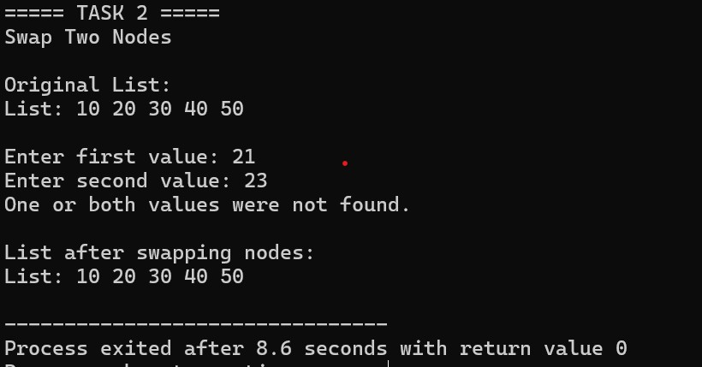

Code #03 #include <iostream> using namespace std;

struct SNode
{ int data;
SNode* next;
};

// Singly List ke Head aur Tail
SNode* sHead = NULL;
SNode* sTail = NULL;

struct DNode
{ int data;
DNode* next;
DNode* prev;
};

// Doubly List ke Head, Tail, First, Last
DNode* head = NULL;
DNode* tail = NULL;

DNode* first = NULL;
DNode* last = NULL;

void insertSingly(int value)
{
SNode* p = new SNode;

p->data = value; p->next = NULL;

// If list is empty if (sHead == NULL)
{
sHead = sTail = p;
}
else
{
sTail->next = p; sTail = p;
}
}

// =====================================================
// DISPLAY SINGLY LINKED LIST
// =====================================================

void displaySingly()
{
SNode* p = sHead;

cout << "Singly Linked List: ";

while (p != NULL)
{
cout << p->data << " "; p = p->next;
}
cout << endl;
}

void insertDoubly(int value)
{
DNode* p = new DNode;

p->data = value; p->next = NULL; p->prev = NULL;

// If list is empty if (first == NULL)
{ first = last = p;

head = tail = p;
}
else
{
last->next = p; p->prev = last;

last = p;
tail = p;
}
}

// =====================================================
// TASK 3
// CONVERT SINGLY INTO DOUBLY
// =====================================================

void convertToDoubly(SNode* sHead)
{
SNode* p = sHead;

// Read singly linked list while (p != NULL)
{
// Same data doubly list mein insert karo insertDoubly(p->data);

p = p->next;
}
}

void displayDoubly()
{
DNode* p = head;

cout << "Doubly Linked List: ";

while (p != NULL)
{
cout << p->data << " "; p = p->next;
}

cout << endl;
}

void displayBackward()
{
DNode* p = tail;

cout << "Doubly List Backward: ";

while (p != NULL)
{
cout << p->data << " "; p = p->prev;
}

cout << endl;
}

int main()
{
cout << "===== TASK 3 =====" << endl; cout << "Singly Linked List to Doubly Linked List"
<< endl;

cout << endl;

// Create Singly Linked List insertSingly(10); insertSingly(20); insertSingly(30); insertSingly(40);

cout << "Before Conversion:" << endl;

displaySingly(); cout << endl;
// Convert Singly to Doubly convertToDoubly(sHead);

cout << "After Conversion:" << endl;

displayDoubly();

displayBackward(); cout << endl; cout << "Head = " << head->data << endl; cout << "First = " << first->data << endl; cout << "Tail = " << tail->data << endl; cout << "Last = " << last->data << endl;

return 0;
}
